Name: Dheeraj Vemula

Coding Challenge

Paper solved: Coding Challenge-4

Creating Database for car rental system which is carrental.

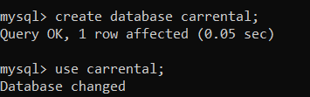

Creating tables named Vehicle, Customer, Lease and Payments.

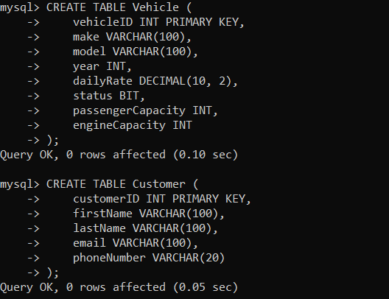

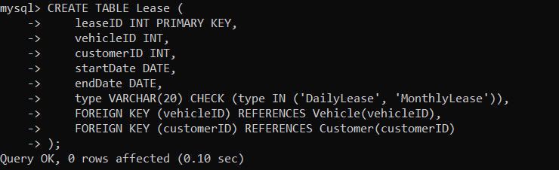

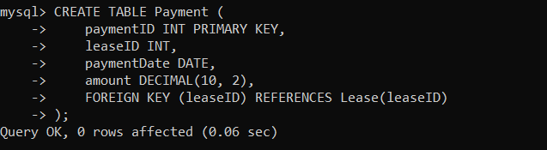

Inserting values into vehicle, customer, lease and payment tables.

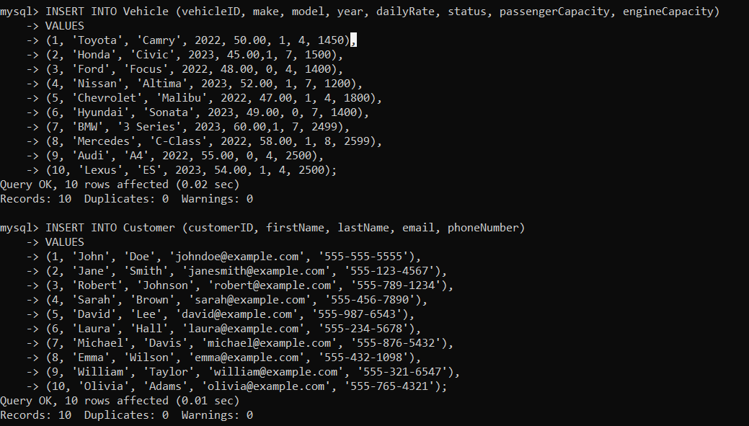

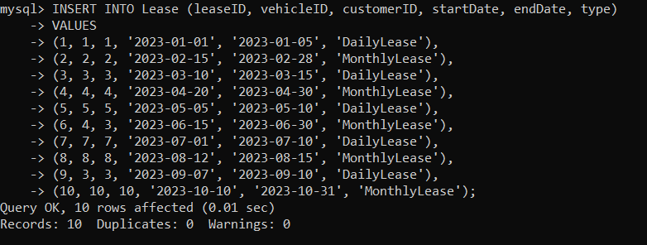

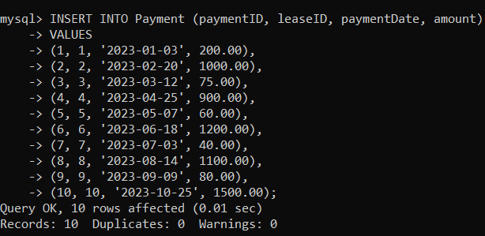

Tasks:

1. Update the daily rate for a Mercedes car to 68.

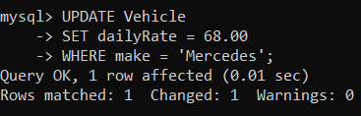

1. Delete a specific customer and all associated leases and payments.

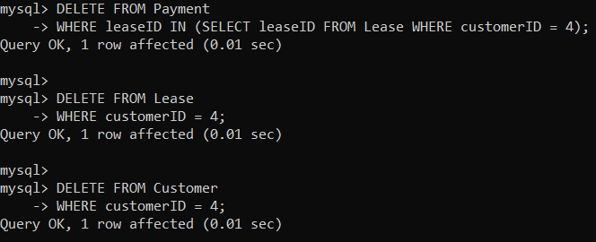

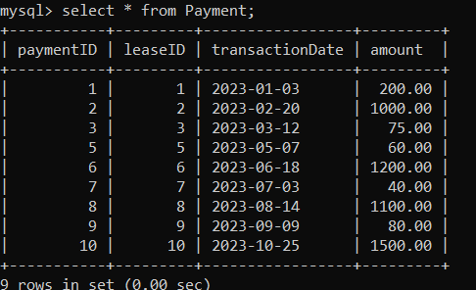

Payments and leases related to customerID =4 is deleted.

1. Rename the "paymentDate" column in the Payment table to "transactionDate".

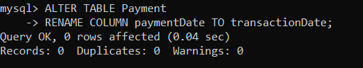

1. Find a specific customer by email.

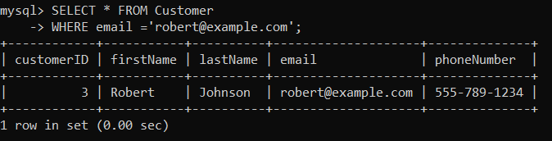

1. Get active leases for a specific customer.

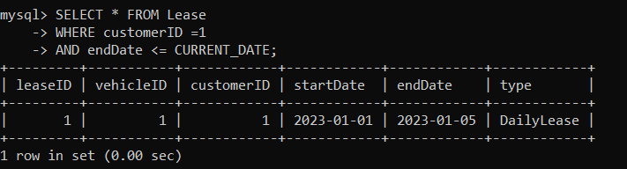

1. Find all payments made by a customer with a specific phone number:

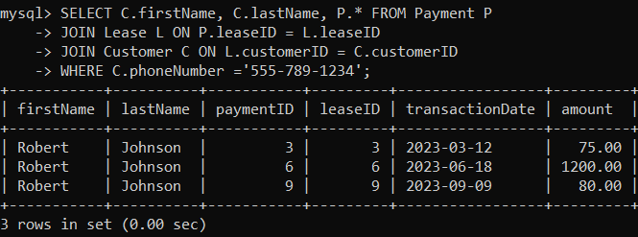

1. Calculate the average daily rate of all available cars:

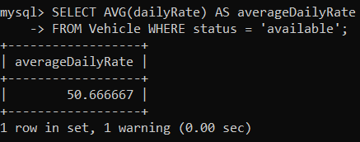

1. Find the car with the highest daily rate.

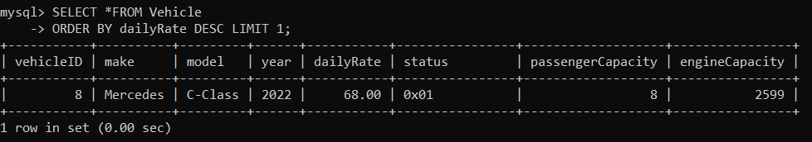

1. Retrieve all cars leased by a specific customer:

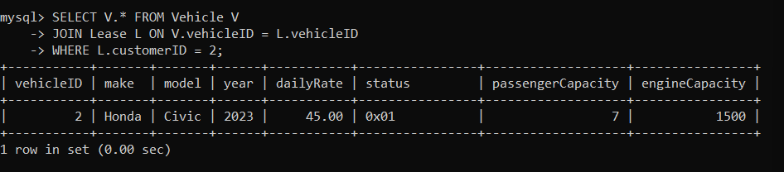

1. Find the details of the most recent lease:

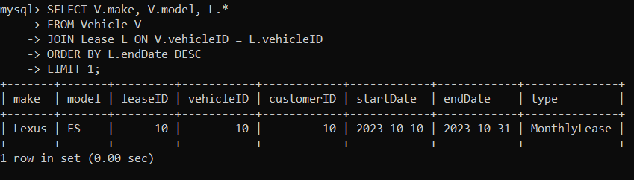

1. List all payments made in the year 2023:

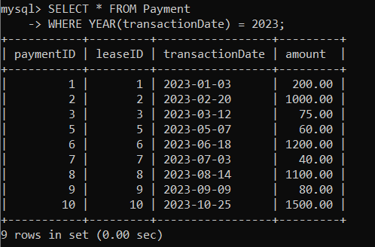

1. Retrieve customers who have not made any payments:

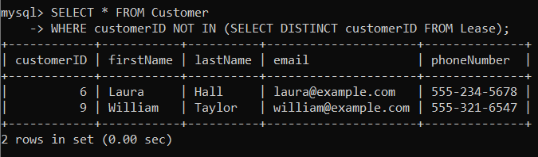

1. Retrieve Car Details and Their Total Payments:

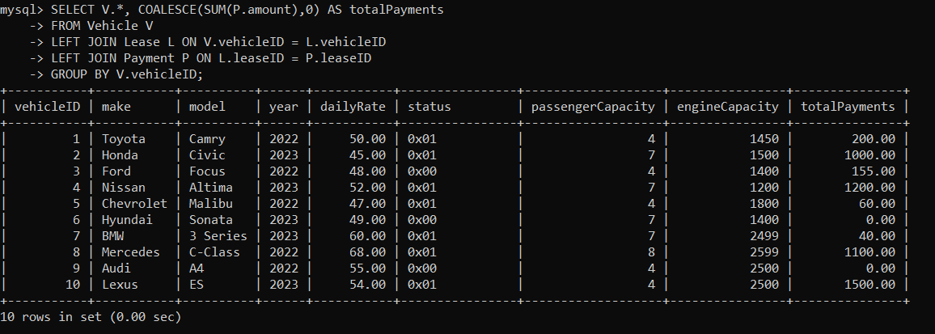

1. Calculate Total Payments for Each Customer:

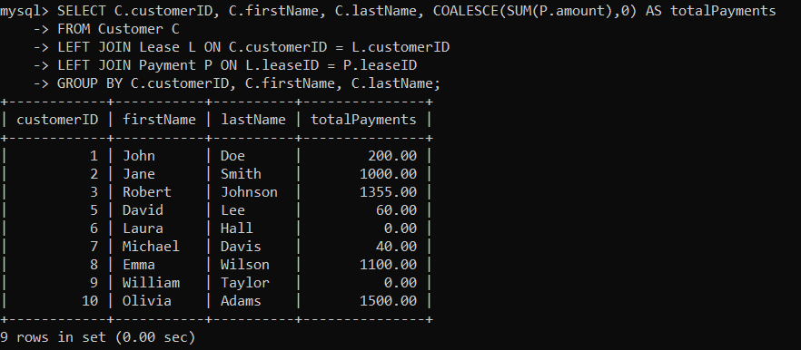

1. List Car Details for Each Lease

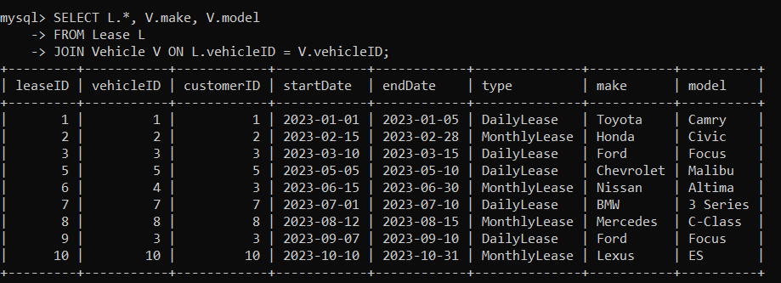

1. Retrieve Details of Active Leases with Customer and Car Information:

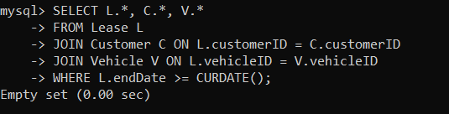

1. Find the Customer Who Has Spent the Most on Leases:

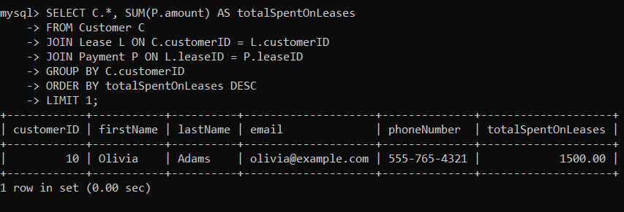

1. List All Cars with Their Current Lease Information:

